To Configure fast, secure file transfers using Amazon S3 Transfer Acceleration.

Step 1: In the AWS Management Console, search for the S3 service and select it

Step 2: Click on Create bucket

Step 3: Now, write the name and region of your bucket

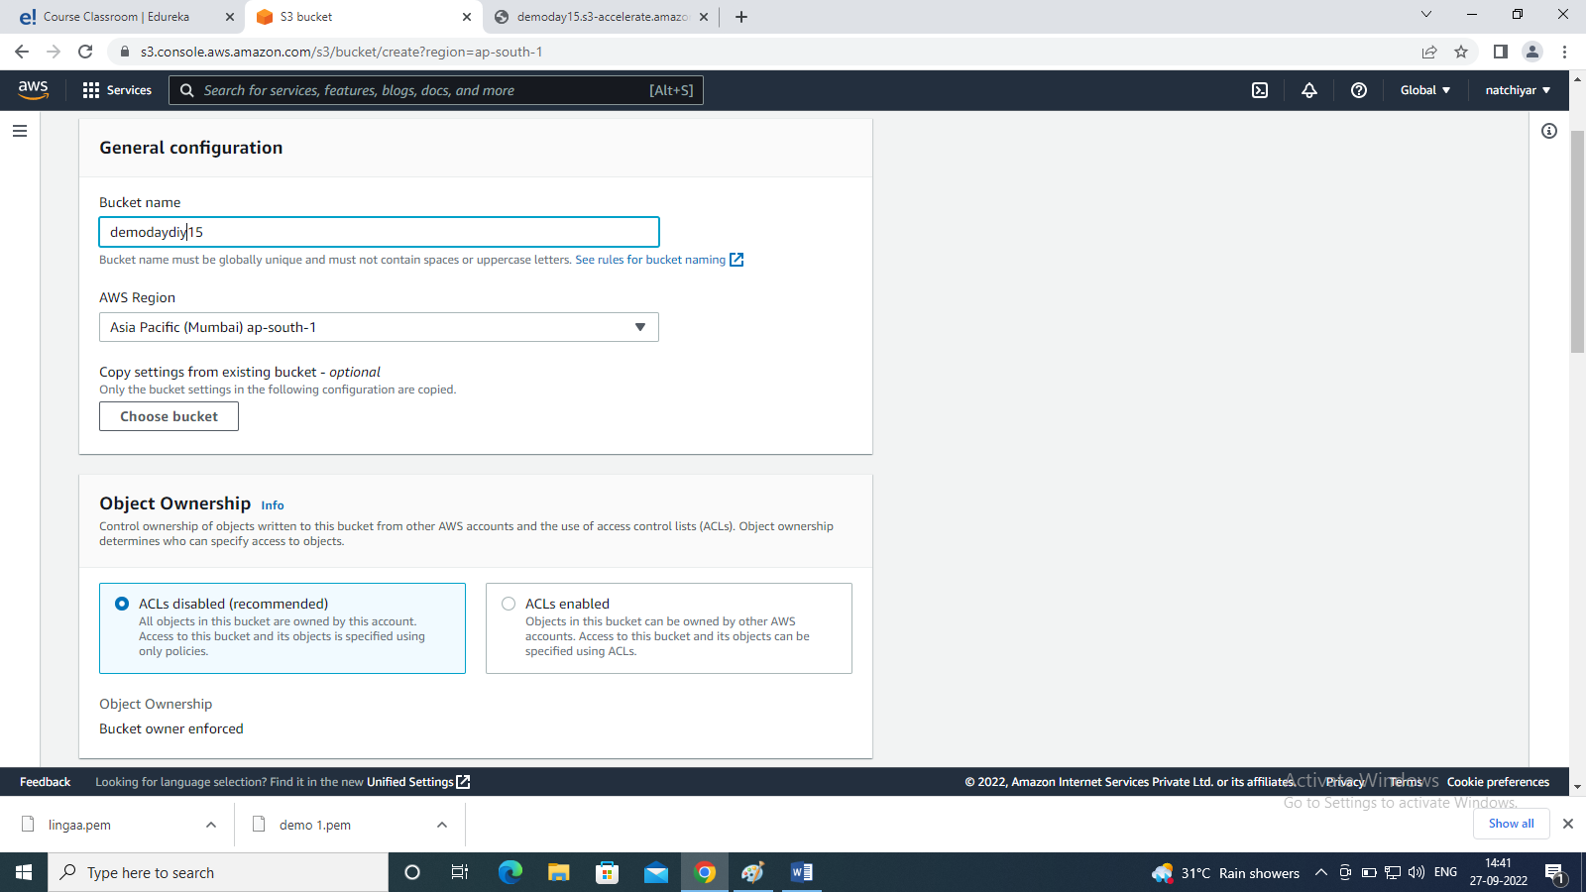

Step 4: click the create bucket button

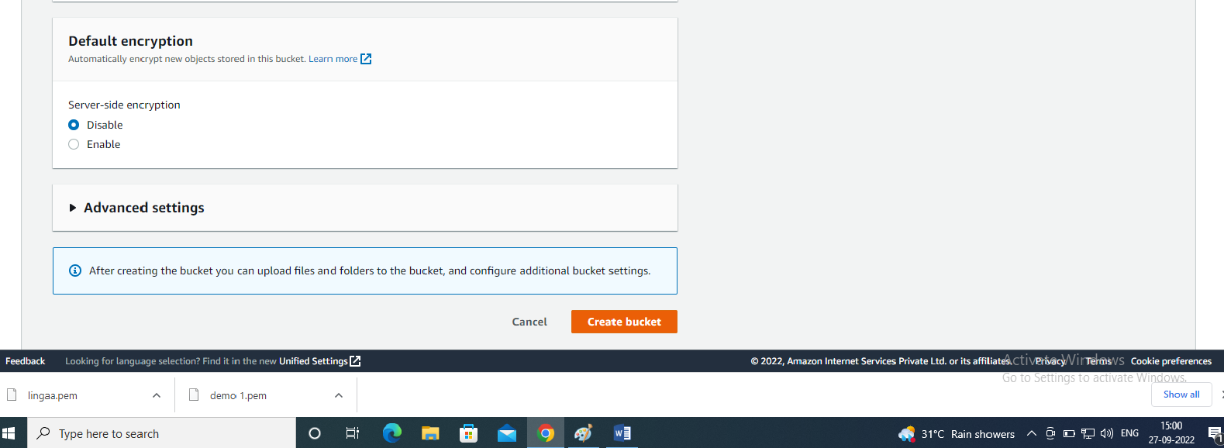

Step 5: Once you have created the bucket, go to properties

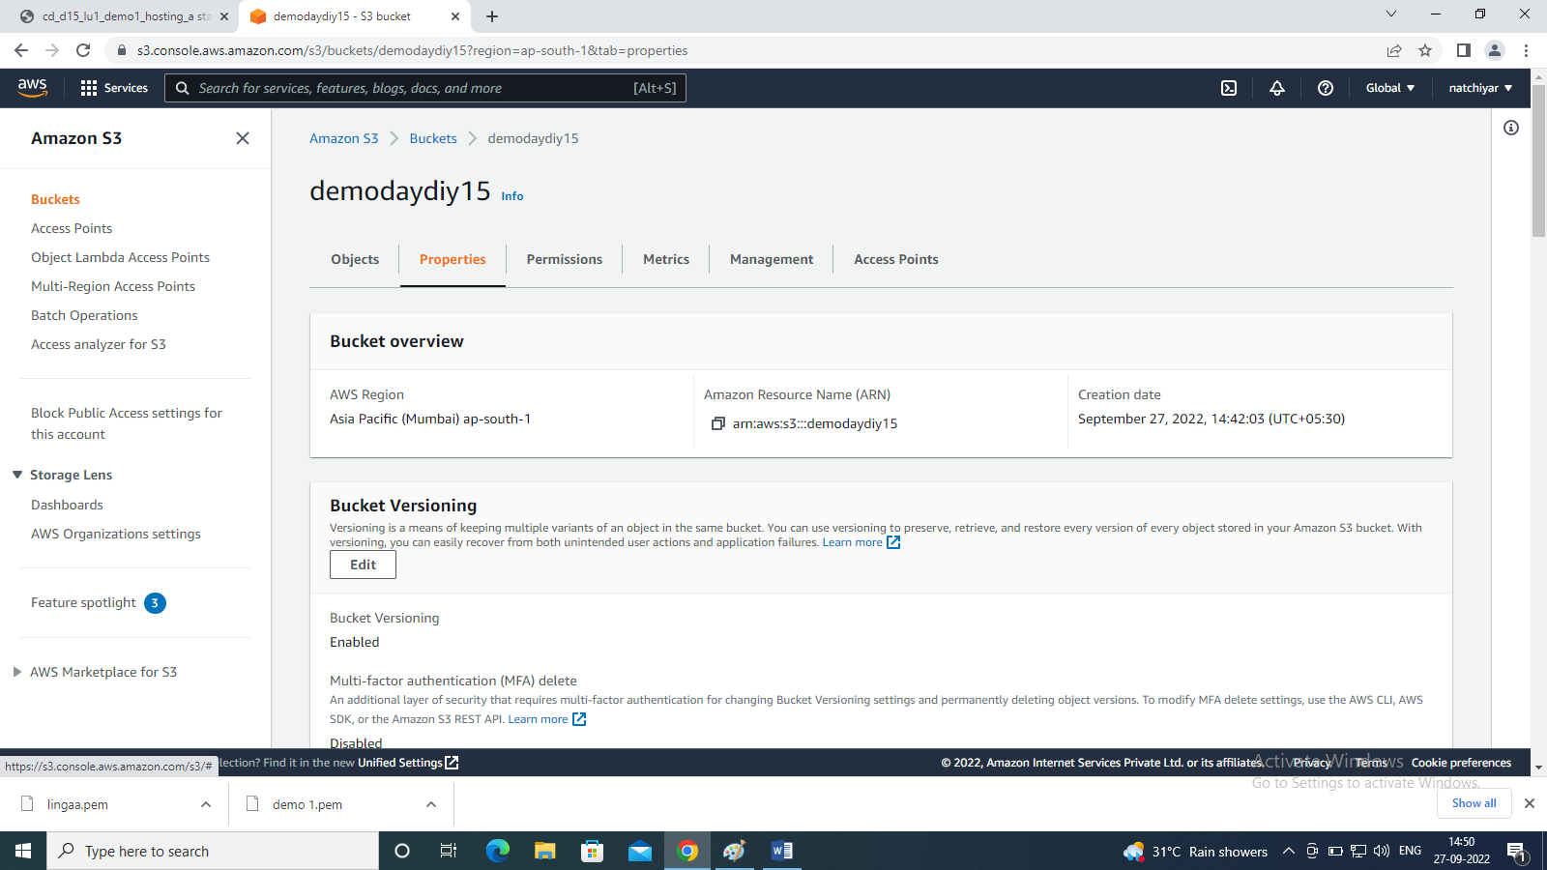

Step 6: scroll down, now you can see transfer acceleration

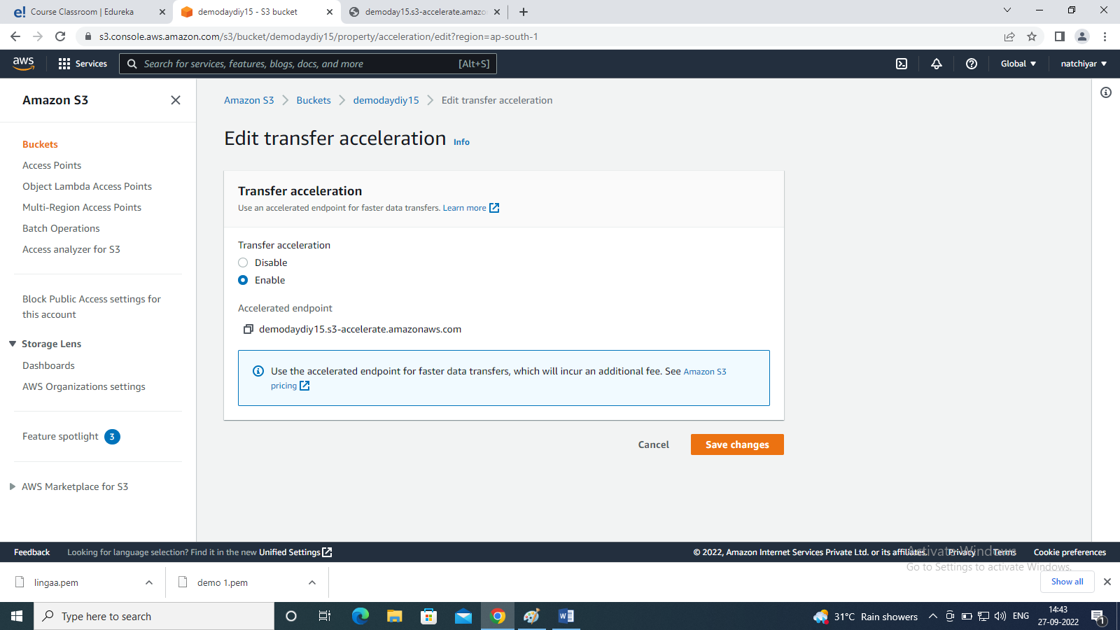

Step 7: Then, we have to enable it and click save changes button

Step 8 : we have successfully enable the Transfer Acceleration.

Q2: Using Requester Pays buckets for storage transfers and usage.

Step 1: In the AWS Management Console, search for the S3 service and select it

Step 2: Click on Create bucket

Step 3: Now, write the name and region of your another bucket

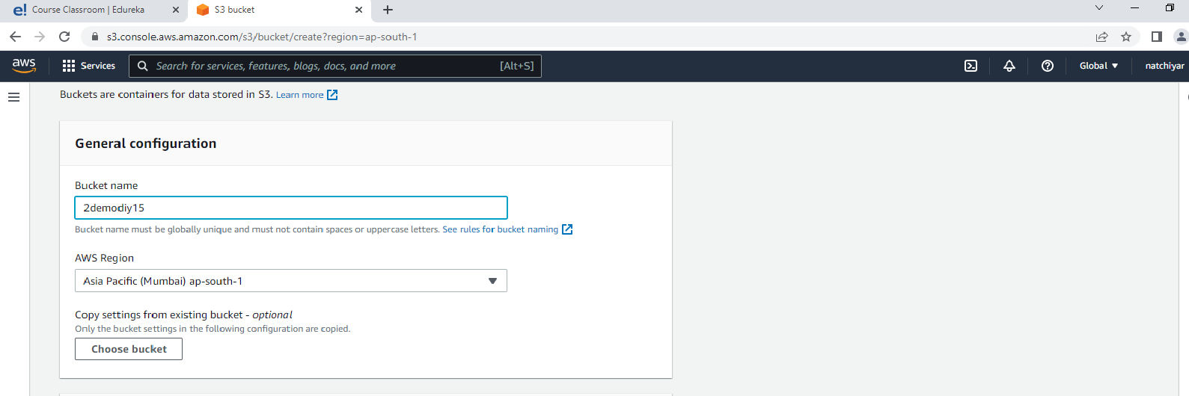

Step 4: click the create bucket button



Step 5: Once you have created the bucket, go to properties

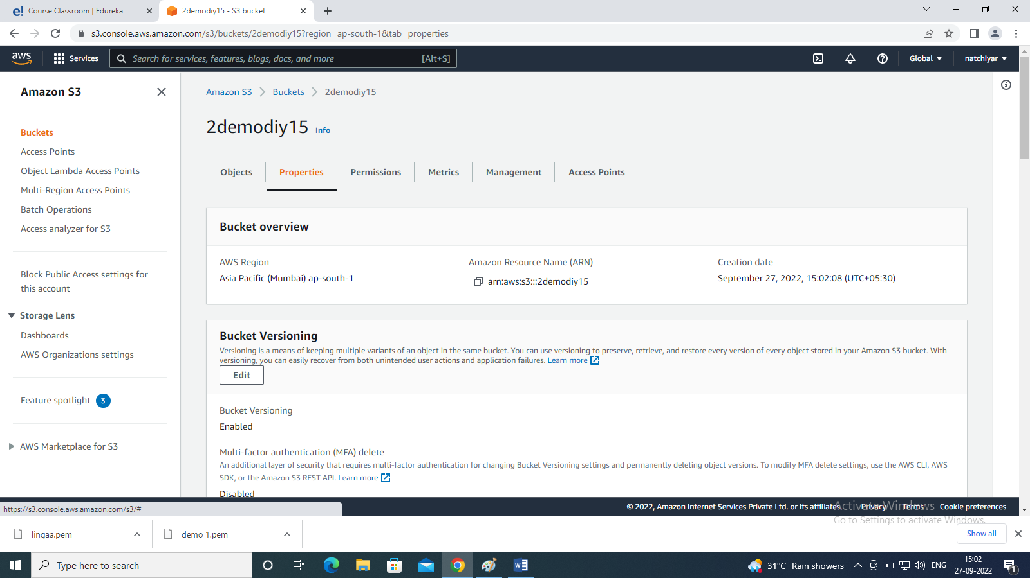

Step 6: scroll down, now you can see request pays

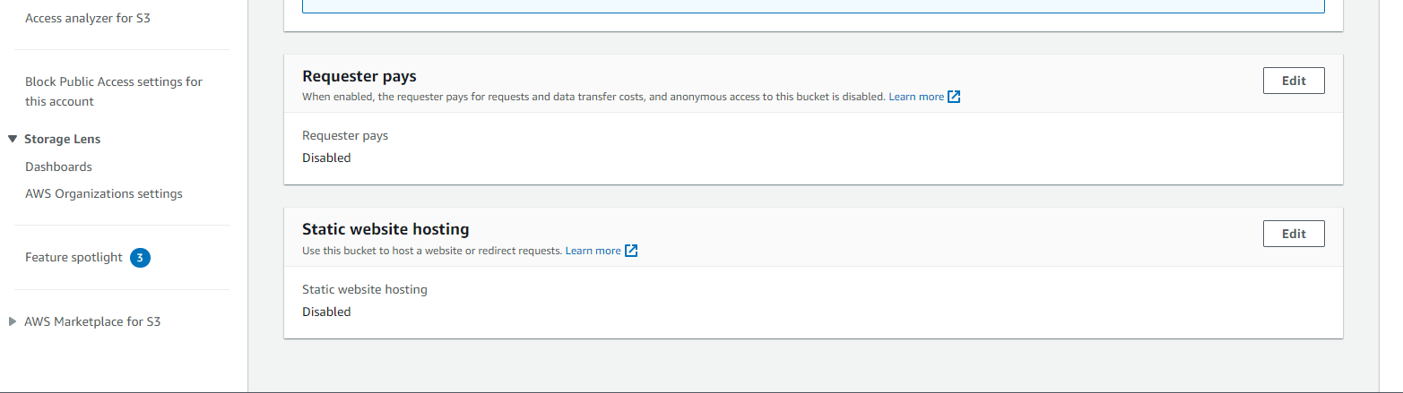

Step 7: click on edit button.

Step 8: Then we have to enable it and click save changes

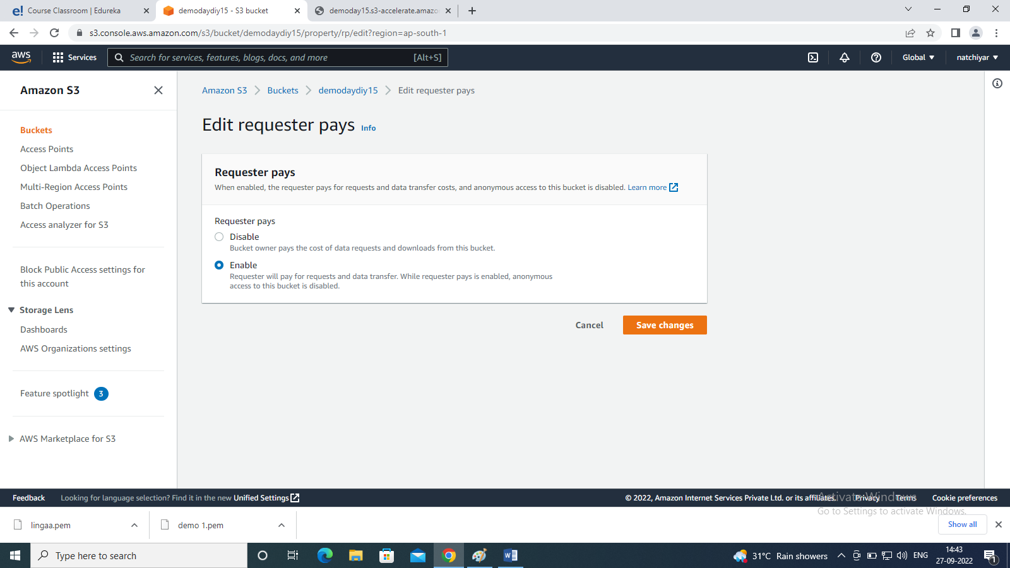

Step 9: we have successfully enable the request pays.